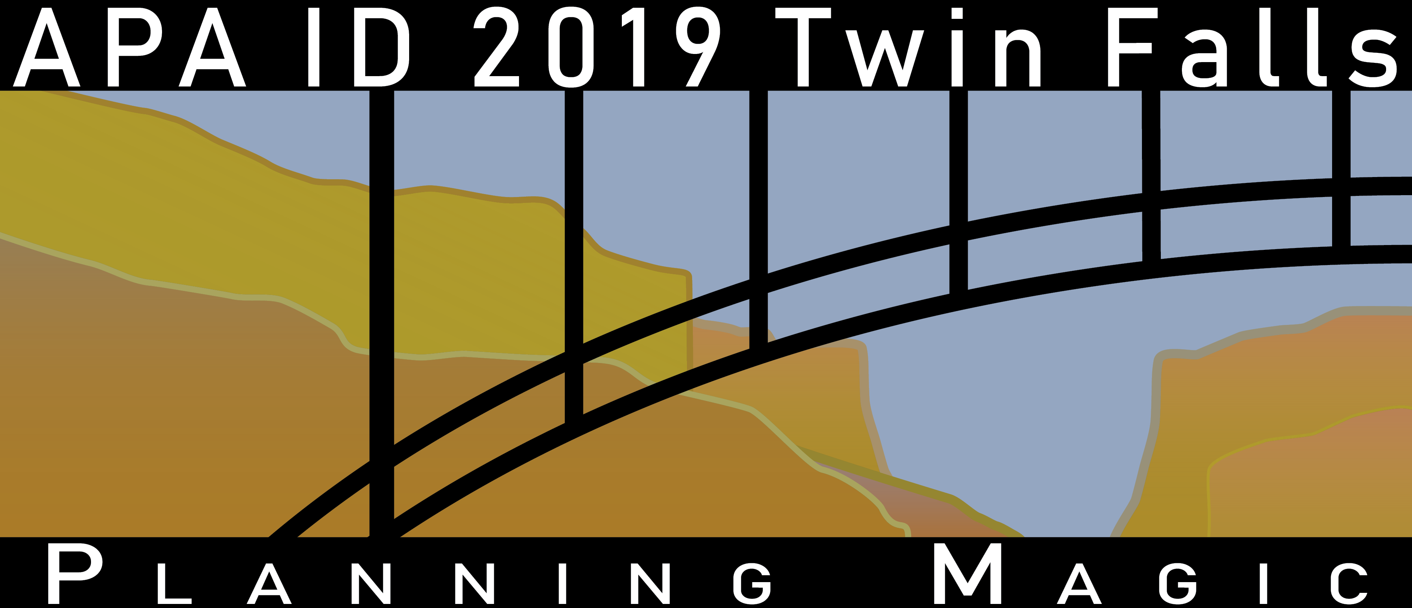
— Call for Presentations —
The American Planning Association, Idaho Chapter is now accepting proposals for session presentations at its 12^{h} annual conference October 2nd – 4th, 2019 in Twin Falls, Idaho. The conference theme this year is "Planning Magic.” The theme “Planning Magic” not only plays off the conference location in the Magic Valley, but also seeks to identify what is the “magic” of planning? Is the magic in partnerships and collaboration? Is the magic in finding new best practices and innovative strategies? Or is the magic something else…? The chapter invites you to take advantage of this opportunity to share your experiences and expertise to further what you feel is the “magic” of the planning profession.
Please submit a complete session proposal for each presentation you propose. Proposals should reflect emerging best practices, dynamic ideas and encourage discussion among participants. Generally, session times are 1:30 p.m. through 5:30 p.m. on Wednesday, October 2nd; 9:30 a.m. to 5:30 p.m. on Thursday, October 3rd; and 9:30 a.m. to 10:30 a.m. on Friday, October 4th. If you have any limitations on your availability, please identify those in the form below.
Session Information
Proposed Session Title:
Brief Session Summary:
Session Format: | ☐ Presentation | ☐ Panel Discussion
(Click on all appropriate boxes) | ☐ Interactive Workshop | ☐ Other (Explain)
 | ☐ Speed Session (See Additional Information)
Target Audience: | ☐ All/General | ☐ Interdisciplinary
 | ☐ Student/New Professional | ☐ Experienced Professional
Continuing Education: | Will session be appropriate for continuing education credits?
 | ☐ YES - AICP | ☐ NO
Audio/Visual Needs: | ☐ Projector ☐ Computer
 | ☐ Other AV needs:
Session Length: | Length of Presentation: ☐ 60 Min. ☐ 90 Min. ☐ 120 Min.
Other Session Notes:

Return this completed form to the 2019 Conference Sessions Subcommittee Member, Steve O’Connor, at soconnor@tfid.org no later than 5 p.m. August 1st, 2019. All session proposals must be completed in MS Word format in order to facilitate the chapter’s preparation of future programs and applications for AICP continuing education credits. You will be notified no later than August 1st if your session is selected for the conference.

Contact Information
Your Name: |  | Title:
Organization:
Address: Street/City/State/Zip:
Phone#: | Email Address:
Your role in session: ☐ Panelist/Speaker ☐ Moderator ☒ Organizer
Will you be registering for the conference:
Panelist/Presenter Information
Speaker Name #1:
Title/Credentials/Organization:
Address: Street/City/State/Zip:
Bio (Max 100 words):

Phone#: | Email Address:

Speaker Name #2:
Title/Organization:
Bio (Max 100 words):

Address: Street/City/State/Zip:
Phone#: | Email Address:
Speaker Name #3:
Title/Organization:
Address: Street/City/State/Zip:
Bio (Max 100 words):

Phone#: | Email Address:
Speaker Name #4:
Title/Organization:
Address: Street/City/State/Zip:
Bio (Max 100 words):

Phone#: | Email Address:

Additional Information
Session Abstract: | Please attach a Word document (500 word limit) describing:  1) How would the session meet the goals of the conference in establishing, discovering, or discussing partnerships, collaboration, new or proven best practices and innovative strategies to further the efforts of the planning profession? Or does it cover current or future issues facing the planning profession?  2) How would the session be applicable to the entry level, mid-career, or upper level professional planners?  3) What will the attendees to learn from this session?
Session Availability: | Please list here any days/times you would be unable to present at the conference.
Speed Sessions: | Speed sessions include 4 to 5 presenters in one session, each presenting on a related topic for 10-15 minutes each with questions at the end. This format will encourage problem solving and collaboration as well a networking around shared challenges. APA Idaho Committee will combine presenters into sessions.
Questions/Help
If you need any additional information or need help completing this form, please contact Steve O’Connor at soconnor@tfid.org or at 208-735-7270 or Brock Cherry at bcherry@tfid.org or 208-735-7294.

